SPI(5-20K)-B2防逆流功能应用
SPI(5-20K)-B2 anti-reflux function application

- SPI(5-20K)-B2逆变器与电表接线示意图
Wiring diagram of SPI(5-20K)-B2 and electricity meter
Meter|DTSD3366G|AC220V|3*10A(80A)| R6
DTSD3366G
Meter
逆变器INV
电网
GRID
负载LOAD
GRID
COM
W
N
switch
switch
switch
1
6
10
RS485
A
B
8
7
A
B
V
U
W
N
V
U
W
N
V
U
4
7
10
9
3
PV

  - 电表的输入和输出接线必须正确，逆变器的交流线缆连接在电表的输入端，电表的输出端连接电网。
The input and output wiring of the meter must be correct. The ac cable of the inverter is connected to the input end of the meter and the output end of the meter is connected to the power grid.
  - 电表的通讯线与逆变器连接必须正确，A、B不能接反。
The communication line of the electricity meter must be connected correctly with the inverter, and A and B cannot be connected inversely.
  - 负载和逆变器连接在电表的同一侧。
The load and inverter are connected on the same side of the meter.
  - COM端口可设置为DRM和RS485通讯端口，均采用RJ45插头连接。
COM. port can set to DRM and RS485 communication port, they all adopt RJ45 plug to connect.

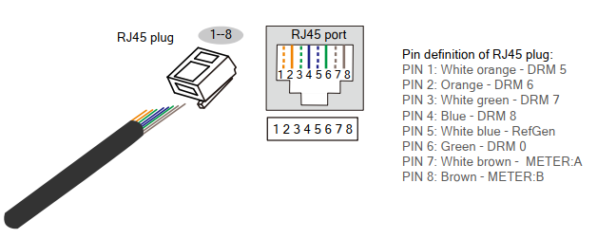

- 逆变器和电表设置Inverter and meter Settings
2.1电表设置Electricity meter setting
DDS3366G型电表，电表的默认通讯地址和波特率。
DDS3366G meter, the default address and baud rate of the meter.
2.2 逆变器设置 Inverter Settings
逆变器设置，可以通过逆变器显示界面进行设置。
Inverter Settings can be set through the inverter display interface
2.2.1 在逆变器显示界面设置 Setup in inverter display interface
用密码000111登录，开关量设置-防逆流使能, 将逆变器关机后，再开机。
Log in with password 000111, switch Settings - countercurrent enabled.
Turn the inverter off and on again.
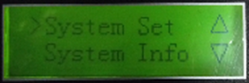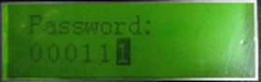

2.2.2 功率定义Power instructions
Reverse (逆向功率)：从电网给的负荷的功率。建议逆向功率设置值不小于0kW。
Reverse power：The power given to the load from the grid.It is recommended that the reverse power setting value be not less than 0kW.
Anticurr Pwr（逆流控制功率）：它允许逆变器向电网供电。
Anticurr power（Countercurrent control power）： It allows the inverter to give power to the grid

例如: 逆向功率设置10%，逆流控制功率设置成30%，电网给负载输出功率5kW*10%=0.5kW，允许逆变器给电网输出最大功率为5kW*30%=1.5kW。
For example：
The reverse power is set at 10%, the Countercurrent control power is set at 30%, the power grid output load is 5kW*10%= 0.5KW, allowing the inverter to output the maximum power to the grid is 5kW*30%= 1.5KW.
The reverse power set
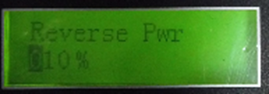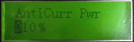

- 功能验证Functional verification
3.1 将通讯线拆除，逆变器会提示通讯故障。证明逆变器与电表通讯正常。
Remove the communication line, the inverter will prompt the communication fault.It is proved that the inverter and the meter communicate normally.
3.2 将通讯线恢复后，通讯告警消除。
After the communication line is restored, the communication alarm is eliminated.
3.3 检查逆变器输出功率与电表显示数据的差异，并记录。
Check the difference between inverter output power and meter display data, and record.

