SPI(1500-6000)-B2防逆流功能应用
SPI(1500-6000)-B2 anti-reflux function application

- 单相组串逆变器与电表接线示意图
Wiring diagram of single-phase series inverter and electricity meter
There are two types of meters：DDS3366D、DDS3366D-1P

DDS3366D-1P meter
逆变器INV
电网GRID
负载LOAD
GRID
COM
L
L
N
N
L
N
L
switch
switch
switch
1
2
4
N
RS485
11
12
8
7
A
B
IN
OUT

DDS3366D meter
逆变器INV
电网GRID
负载LOAD
GRID
COM
L
L
N
N
L
N
L
switch
switch
switch
N
RS485
A
B
8
7
A
B
IN
OUT
针对两款电表的接线方式，如上图所示。
The wiring mode of the two types of electricity meters is shown in the figure above.
  - 电表的输入和输出接线必须正确，逆变器的交流线缆连接在电表的输入端，电表的输出端连接电网。
The input and output wiring of the meter must be correct. The ac cable of the inverter is connected to the input end of the meter and the output end of the meter is connected to the power grid.
  - 电表的通讯线与逆变器连接必须正确，A、B不能接反。
The communication line of the electricity meter must be connected correctly with the inverter, and A and B cannot be connected inversely.
  - 负载和逆变器连接在电表的同一侧。
The load and inverter are connected on the same side of the meter.

- 逆变器和电表设置
Inverter and meter Settings
2.1电表设置Electricity meter setting
1) DDS3366D型电表，需要设置电表通讯地址为1。
DDS3366D meter, the communication address of the meter should be set as 1.
2) DDS3366D-1P型电表，电表的默认通讯地址为1
DDS3366D -1p meter, the default communication address of the meter is 1

2.2 逆变器设置 Inverter Settings
逆变器设置，可以通过逆变器显示界面或wiseenergy界面进行设置。
Inverter Settings can be set through the inverter display interface or the wiseenergy interface
2.2.1 在逆变器显示界面设置 Setup in inverter display interface
用密码000111登录，开关量设置-防逆流使能, 将逆变器关机后，再开机。
Log in with password 000111, switch Settings - countercurrent enabled.
Turn the inverter off and on again.
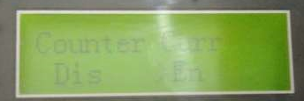

例如:设置成20%，可以给电网输出最大功率为5kW*20%=1kW。
For example：Set to 20%, the maximum output power to the power grid is 5kW*20%= 1 kW

2.2.1 在WiseEnergy 设置 In the WiseEnergy setting
登录WiseEnergy，Reflux DisEn 设置 enable. Reflux Power 根据需求设置功率。Logon WiseEnergy, Reflux DisEn sets enable, Reflux Power sets the Power according to the demand.
例如:设置成20%，可以给电网输出最大功率为5kW*20%=1kW。
For example：Set to 20%, the maximum output power to the power grid is 5kW*20%= 1 kW
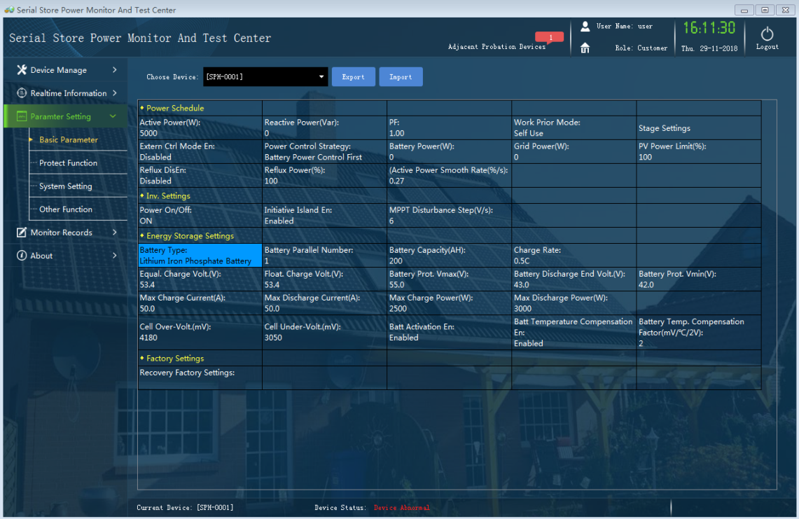
- 功能验证Functional verification
3.1 将通讯线拆除，逆变器会提示通讯故障。证明逆变器与电表通讯正常。
Remove the communication line, the inverter will prompt the communication fault.It is proved that the inverter and the meter communicate normally.
3.2 将通讯线恢复后，通讯告警消除。
After the communication line is restored, the communication alarm is eliminated.
3.3 检查逆变器输出功率与电表显示数据的差异，并记录。
Check the difference between inverter output power and meter display data, and record.

